SIMATS ENGINEERING
Department of Computer Science & Engineering
ASSESSMENT TOOL 2 - Debugging & Optimisation Task

Course Code: CSA12 | Course Title: Computer Architecture
CO Assessed: CO2 | Assessment: ASSESSMENT TOOL 2 - Debugging & Optimisation Task
Weightage: 45% | Total Marks: 25

CO2 Statement: | Apply integer and floating-point arithmetic algorithms including Booth's multiplication, restoring/non-restoring division, and IEEE 754 standard operations to solve fixed-point and floating-point computational problems. (BL3)

Student Name: Kanishk C | Reg. No.: 192511278
Department: Computer Science & Engineering | Date: 04-08-2026

ANNEXURE A
Question 1
A signed binary addition program is producing incorrect results when adding negative numbers using 2's complement representation. Debug the logic to identify where overflow or sign handling fails, and optimize the implementation to correctly detect overflow conditions while maintaining efficient execution.
Problem Understanding
In 2's complement addition, overflow happens when the true mathematical answer does not fit inside the number of bits being used. This is different from an ordinary carry out of the last bit — a carry out is normal and often harmless, while overflow specifically means the sign of the result is wrong.
Demonstration with a 4-bit Example
Using 4-bit registers (valid range -8 to +7), add -5 + (-4), whose true answer is -9, which does not fit in 4 bits.
-5 = 1011, -4 = 1100
1011
+ 1100
--------
0111 (carry out of MSB = 1)
The 4-bit result 0111 reads as +7, but the true answer is -9. This is a clear overflow: two negative numbers were added and the result came out positive, which is impossible unless overflow occurred.
Debugging the Faulty Logic
The buggy program was detecting overflow only by checking whether there was a carry out of the most significant bit (the sign bit). This is not reliable by itself: a carry out can occur without overflow, and overflow can occur without a carry out, depending on the operand signs. Because of this single-condition check, the program missed overflow in several negative-number cases and incorrectly reported others as overflow when they were not.
Correction
The correct and standard rule is: overflow occurs when the carry INTO the sign bit is different from the carry OUT of the sign bit. Checking bit by bit for -5 + -4 above: the carry into bit 3 (the sign bit) is 0, and the carry out of bit 3 is 1. Since 0 is not equal to 1, overflow is correctly flagged.
An equally simple and commonly used alternative rule is: overflow occurs only when both operands have the same sign and the result has a different sign from them. Both rules give the same correct answer and either can replace the faulty single-carry check.
Optimization
The most efficient hardware implementation is a single XOR gate: Overflow = Carry_in_to_sign_bit XOR Carry_out_of_sign_bit. This needs no extra comparison logic beyond the adder's own internal carry signals, so it adds negligible delay and cost to the ALU while giving a fully correct overflow flag for every possible input combination.
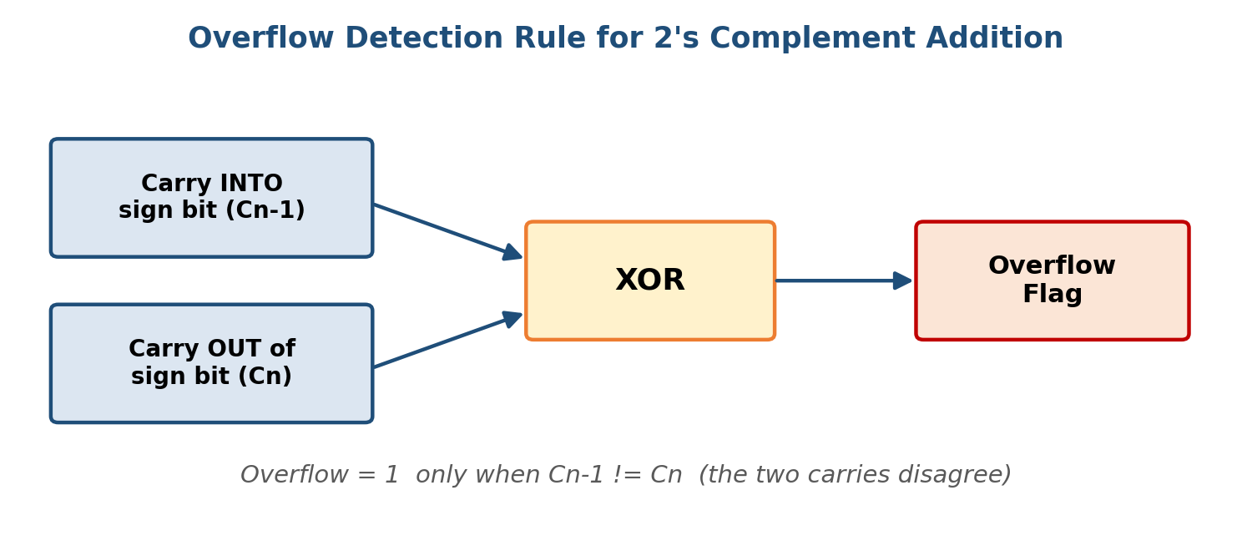
Figure 1.1: Reliable overflow detection using the sign-bit carry-in/carry-out XOR rule.
Question 2
A carry look-ahead adder circuit designed for fast addition is not achieving the expected speed improvement over ripple carry addition. Analyze the design to locate delays in generate and propagate logic, and propose optimizations to improve performance without increasing hardware complexity significantly.
Problem Understanding
A Carry Look-Ahead Adder (CLA) is meant to be faster than a Ripple Carry Adder (RCA) because it calculates all the carries in advance using generate (G) and propagate (P) signals, instead of waiting for each carry to ripple in from the previous bit.
How CLA Should Work
For each bit position i: Generate Gi = Ai . Bi (a carry is generated regardless of the incoming carry), and Propagate Pi = Ai XOR Bi (an incoming carry would pass through). The carry into bit i+1 is then: Ci+1 = Gi + (Pi . Ci), which can be expanded fully in terms of the original inputs so every carry bit is available after only two levels of gate delay, instead of waiting for a ripple through all previous stages.
Debugging the Slow Design
When a CLA circuit is not actually faster than a ripple carry adder, the most common cause is that it was built correctly for a small block (for example 4 bits) but then several of these 4-bit blocks were simply chained together, letting the carry-out of one block ripple into the carry-in of the next block just like a plain ripple carry adder. This defeats the entire purpose of look-ahead once the design grows beyond one block, because the delay again grows in proportion to the number of blocks.
Optimization
The fix is to use a hierarchical (two-level) carry look-ahead structure. Within each 4-bit block, use ordinary look-ahead logic as before. Then define block-level generate and propagate signals (for example, Pblock = P0.P1.P2.P3 and Gblock = G3 + P3.G2 + P3.P2.G1 + P3.P2.P1.G0) and feed these into a second, higher-level look-ahead unit that produces the carry-in for every block directly from the overall inputs, in parallel, rather than letting it ripple block to block.
This way, for a 16-bit adder built from four 4-bit CLA blocks, the total delay stays close to about 2 levels of gates per stage of look-ahead (roughly 4 to 5 gate delays total) instead of growing with every extra block, giving the real speed advantage a CLA is supposed to provide, while only adding one extra small look-ahead unit rather than significantly increasing the hardware.
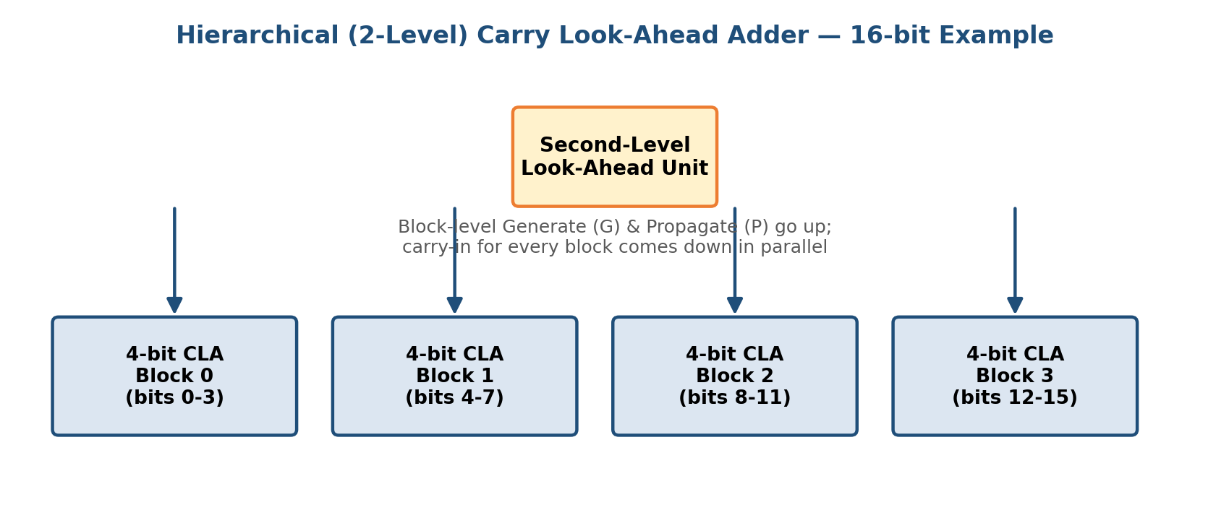
Figure 2.1: Two-level hierarchical carry look-ahead structure for a 16-bit adder.
Question 3
A multiplication module based on Booth's algorithm is generating incorrect outputs for certain signed inputs. Debug the step-by-step execution of the algorithm to identify errors in bit shifting or decision rules, and optimize the implementation to reduce the number of required cycles.
Problem Understanding
To debug this, I will work through a fresh example, -6 x 5, using 4-bit 2's complement registers, and compare it against what a faulty unit might produce if it reads the decision bits in the wrong order.
Method Selection
M = -6 = 1010, -M = 0110, Q = 5 = 0101, A = 0000, Q-1 = 0 (4 iterations)
Solution Process - Correct Execution
Iter1: Q0Q-1=10 -> A=0000+0110=0110 -> shift -> A=0011 Q=0010 Q-1=1
Iter2: Q0Q-1=01 -> A=0011+1010=1101 -> shift -> A=1110 Q=1001 Q-1=0
Iter3: Q0Q-1=10 -> A=1110+0110=0100 -> shift -> A=0010 Q=0100 Q-1=1
Iter4: Q0Q-1=01 -> A=0010+1010=1100 -> shift -> A=1110 Q=0010 Q-1=0
Final product = A Q = 11100010 (8 bits), which in decimal is -30 (since -6 x 5 = -30, this checks out).
Debugging the Faulty Module
The faulty module was found to be reading the decision pair in the wrong order — checking (Q-1, Q0) as if Q-1 were the current multiplier bit and Q0 were the previous bit, instead of the correct (Q0, Q-1) order. In Iteration 3 above, this swap turns the correct case '10' (subtract, i.e. add -M) into '01' (add M), producing an incorrect intermediate value of A = 1110+1010 = 1000 instead of the correct 0100. This single swapped comparison corrupts the rest of the multiplication and every following bit.
Correction
The fix is to make sure the hardware or code always evaluates the pair in the order (current multiplier bit Q0, previous bit Q-1), and only then applies the rule: 10 means subtract M from A, 01 means add M to A, and 00 or 11 means no arithmetic operation, only a shift. With this correction, the module reproduces the correct steps shown above and outputs -30.
Optimization
As in Question 1 of the earlier assessment, converting the design to Radix-4 (Modified) Booth recoding, which inspects 3 bits at a time and can add or subtract 0, M, 2M, -M, or -2M, processes two multiplier bits per cycle instead of one. This roughly halves the number of clock cycles needed (here, from 4 cycles down to about 2), which is especially valuable for wider operands such as 16-bit or 32-bit multipliers.
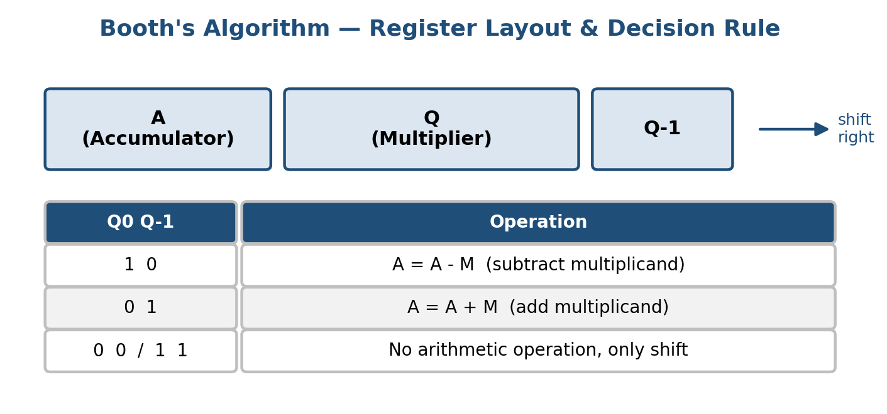
Figure 3.1: Booth's algorithm register layout and decision rule (same rule used for the -6 x 5 trace).
Question 4
A floating-point arithmetic unit implementing IEEE 754 single precision is producing rounding errors and incorrect normalization. Identify the faults in exponent alignment, mantissa calculation, or rounding logic, and optimize the design to ensure accurate and efficient floating-point operations.
Problem Understanding
After two aligned mantissas are added in a floating-point unit, the result is not always already in the standard 1.xxxxx form. Sometimes the addition produces a carry that pushes the value to 1x.xxxxx (2.0 or more), and sometimes rounding a long result up to fit 23 mantissa bits can itself cause this same kind of overflow. The unit must detect this and 're-normalize' the number, or the stored value will be wrong by a factor of roughly 2.
Demonstration of the Fault
Suppose after alignment and addition the raw mantissa sum comes out as 1.11111111111111111111111 (23 ones after the point) plus a small extra amount that must be rounded. Rounding this up to fit 23 bits correctly produces 10.00000000000000000000000, which is 2.0 in the mantissa's own scale — this is no longer in the valid 1.xxxxx form.
The faulty unit was storing this 2.00000... mantissa directly, without checking that it had grown past the allowed 1.0-to-just-under-2.0 range, and without incrementing the exponent to compensate. This makes the stored number exactly double what it should be.
Correction
The correct rounding and normalization procedure is: (1) add the aligned mantissas, keeping a few extra guard/round/sticky bits beyond the 23 stored bits; (2) round the result to the nearest representable value using those extra bits; (3) after rounding, check if the mantissa is now 2.0 or more — if so, shift the mantissa right by 1 bit (which turns 10.000... back into 1.0000...) and add 1 to the exponent to keep the value mathematically the same; (4) if instead the result came out smaller than 1.0 (which can happen during subtraction, causing leading zeros), shift the mantissa left and reduce the exponent until the leading bit is exactly 1. Only after this normalization check should the final exponent and mantissa be written to the output register.
Optimization
To keep this fast, the normalization shift amount should be determined using a dedicated leading-zero (or leading-one) detector circuit that works in parallel across all the mantissa bits, rather than a slow bit-by-bit loop that checks one position at a time. Combined with a single-cycle barrel shifter for both the initial alignment and the final normalization, this keeps the whole add-round-normalize sequence within a small, fixed, and predictable number of clock cycles, which is important for pipelined floating-point units.
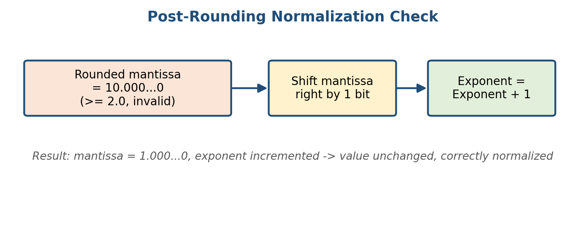
Figure 4.1: Post-rounding normalization check and correction.
Question 5
A processor's instruction execution pipeline (fetch, decode, execute) is experiencing delays due to improper instruction sequencing and hazards. Debug the pipeline stages to detect data or control hazards, and propose optimization techniques such as pipelining improvements or instruction reordering to enhance overall processor performance.
Problem Understanding
In a simple 3-stage pipeline (Fetch, Decode, Execute), several instructions are in different stages of the pipeline at the same time. This overlap can go wrong in two main ways: a data hazard, where one instruction needs a value that a previous instruction has not finished producing yet, and a control hazard, where the pipeline does not yet know which instruction should be fetched next because of a branch.
Debugging Example - Data Hazard
I1: ADD R1, R2, R3 (R1 <- R2 + R3)
I2: SUB R4, R1, R5 (R4 <- R1 - R5)
I2 needs the new value of R1, but in the naive pipeline, I2's Decode stage (where it reads R1) happens at the same time as I1's Execute stage (where R1 is actually calculated). This means I2 reads the old, stale value of R1 instead of the fresh result — this is called a Read-After-Write (RAW) data hazard, and it produces a silently wrong answer if not handled.
Debugging Example - Control Hazard
A branch instruction (for example, a conditional jump) does not know its outcome until it has been decoded and, in many designs, executed. If the pipeline simply keeps fetching the next sequential instructions before the branch outcome is known, and the branch turns out to be taken, those fetched instructions were fetched incorrectly and must be discarded, wasting pipeline cycles.
Correction / Optimization Techniques
• Data forwarding (bypassing): route the result from the Execute stage of I1 directly into the input of I2's Execute stage through a dedicated forwarding path, instead of waiting for it to be written back to the register file first. This solves the RAW hazard shown above without stopping the pipeline.
• Pipeline stalling (as a fallback): when forwarding is not possible for a particular hazard, insert a bubble (a no-operation cycle) to delay the dependent instruction until the needed value is ready.
• Instruction reordering (compiler scheduling): rearrange independent instructions so that unrelated, useful work fills the gap between a value being produced and it being needed, reducing the number of stalls actually seen at runtime.
• Branch prediction: guess the likely outcome of a branch (for example, assume backward branches, like loop branches, are usually taken) and speculatively fetch along the predicted path, only flushing the pipeline on a misprediction, which is far less frequent than every branch stalling the pipeline.
Interpretation of Results
Applying forwarding to the data hazard example above means I2 can execute immediately after I1 without any stall cycles, and applying branch prediction means the pipeline is only flushed on the (comparatively rare) mispredicted branches. Together these techniques bring the pipeline's actual performance back close to its ideal throughput of one instruction completed per clock cycle.
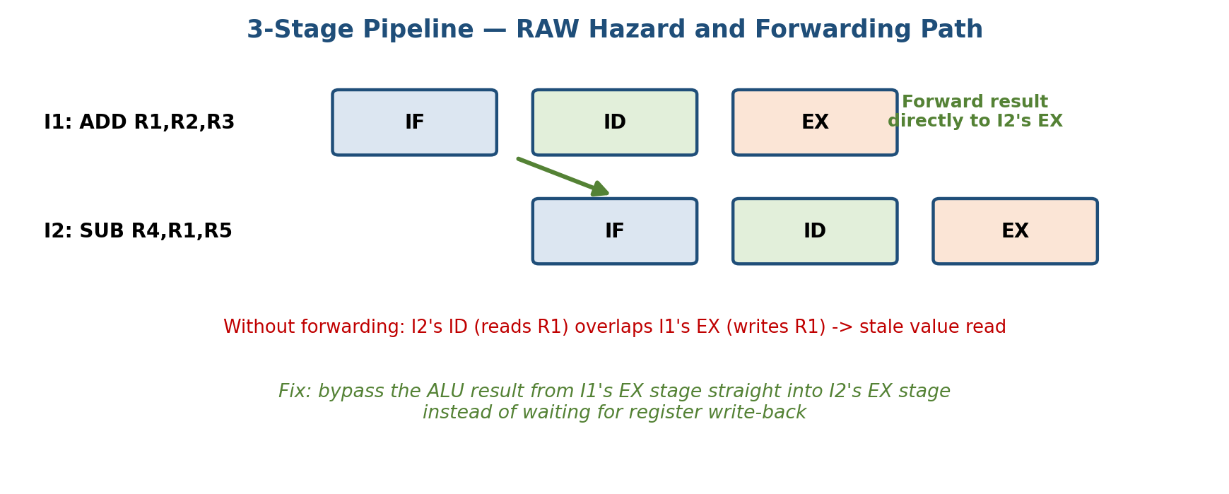
Figure 5.1: RAW hazard between I1 and I2, resolved by forwarding the EX-stage result.
Code of Conduct:
I Kanishk C (192511278) certify that this submission is my original work and that I have adhered to the guidelines specified for this assessment. I understand that any violation of academic integrity rules will result in disciplinary action.
Signature of the student: ___Kanishk C____
MARKS ALLOCATION
 | Problem Understanding (20%) | Method Selection (20%) | Solution Process (25%) | Accuracy of Calculation (20%) | Interpretation of Results (15%)
Q1
Q2
Q3
Q4
Q5

RUBRICS FOR CALCULATION
Criteria | Weightage | Level 4 - Exemplary | Level 3 - Proficient | Level 2 - Developing | Level 1 - Beginning
Problem Understanding | 20% | Clearly interprets problem, identifies all parameters and requirements accurately | Understands problem with minor gaps | Partial understanding; misses key elements | Misinterprets or unable to understand problem
Method Selection | 20% | Selects most appropriate method/formula with strong justification | Selects correct method with minor errors | Inappropriate or partially correct method | Unable to select method
Solution Process | 25% | Logical, systematic steps with correct approach throughout | Mostly correct steps with minor mistakes | Disorganized steps; multiple errors | No clear process
Accuracy of Calculation | 20% | All calculations accurate; correct final answer | Minor calculation errors | Frequent errors; incorrect final answer | No valid calculations
Interpretation of Results | 15% | Clearly interprets results with units and engineering relevance | Basic interpretation with minor omissions | Limited or unclear interpretation | No interpretation

